**Geological Picnic in Iowa, April 28, 1894**

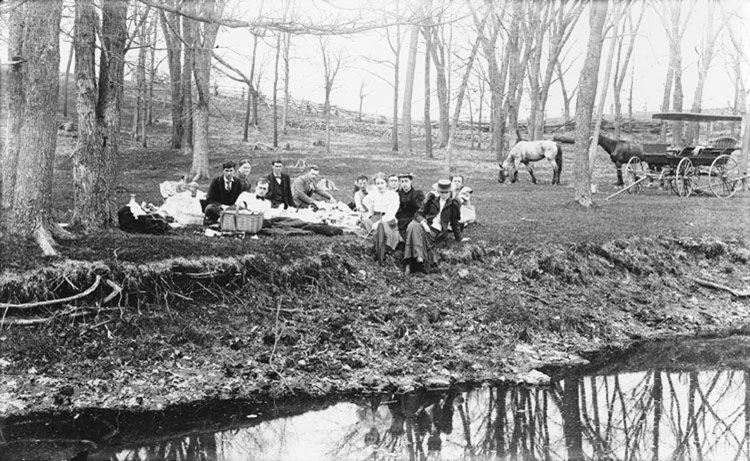

"Geological picnic, Iowa, April 28, 1894," 29 April 1894. [Courtesy of University of Iowa Libraries](http://digital.lib.uiowa.edu/cdm/singleitem/collection/calvin/id/576/rec/5)

**Title:** Geological Picnic in Iowa, April 28, 1894

**Description:** A group of geologists in 1894 are exploring the Iowa landscape. The individuals are seen having a picnic during their exploration.

**Question:** The geologists in this photo were exploring the land. Looking at the landscape in the photo, do you think this would be a good place to build railroad tracks? Why or why not?

**Kansan Topography in Coralville, Iowa, between 1895 and 1910**

[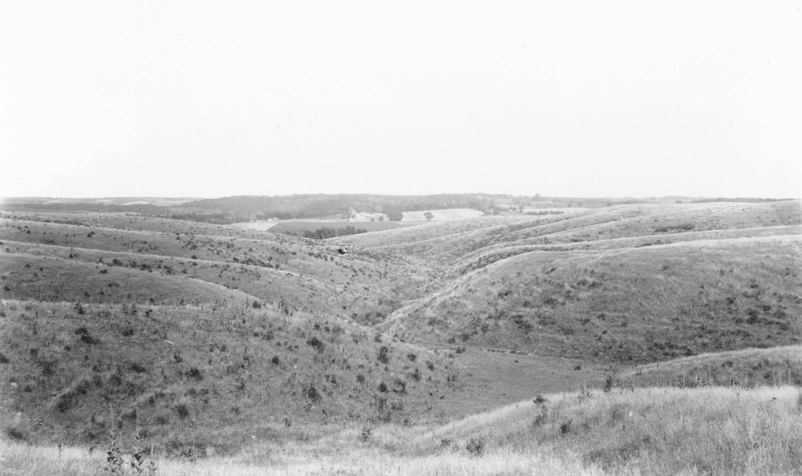](https://iowaculture.gov/sites/default/files/primary-sources/images/history-education-pss-geography-kansan-source.jpg)

Calvin, Samuel, "Kansan topography, showing mature topography developed by erosional loess overlying Kansan drift; Coralville, Iowa, late 1890s or early 1900s," between 1895 and 1910. [Courtesy of University of Iowa Libraries](http://digital.lib.uiowa.edu/cdm/singleitem/collection/calvin/id/635/rec/380)

**Title:** Kansan Topography in Coralville, Iowa, between 1895 and 1910

**Description:** The photo features Kansan topography from the late 1890s or early 1900s. The image shows mature topography developed by erosional loess overlying Kansan drift in Coralville, Iowa.

**Question:** The railroad surveyors, architects and engineers had to consider many different landforms in Iowa. What would be involved with planning and laying a railroad line in this area?

**Limestone Cliff in Durango, Iowa, between 1895 and 1910**

[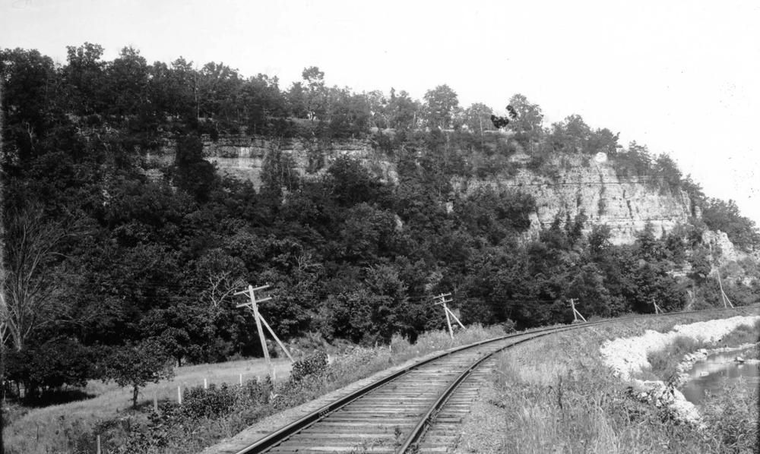](https://iowaculture.gov/sites/default/files/primary-sources/images/history-education-pss-geography-limestone-source.jpg)

Calvin, Samuel, "Limestone cliff, Durango, Iowa, late 1890s or 1900s," between 1895 and 1910. [Courtesy of University of Iowa Libraries](http://digital.lib.uiowa.edu/cdm/singleitem/collection/calvin/id/18/rec/88)

**Title:** Limestone Cliff in Durango, Iowa, between 1895 and 1910

**Description:** The Galena Limestone cliff next to the railroad was photographed between 1895 and 1910 in Durango, Iowa. Durango is located in Dubuque County on the eastern border of the state near the Mississippi River.

**Question:** Notice the geography in this area. What would have been challenging for people to plan and build a railroad line in this particular area?

**Railroad Cut Through Maquoketa Shales, between 1895 and 1910**

[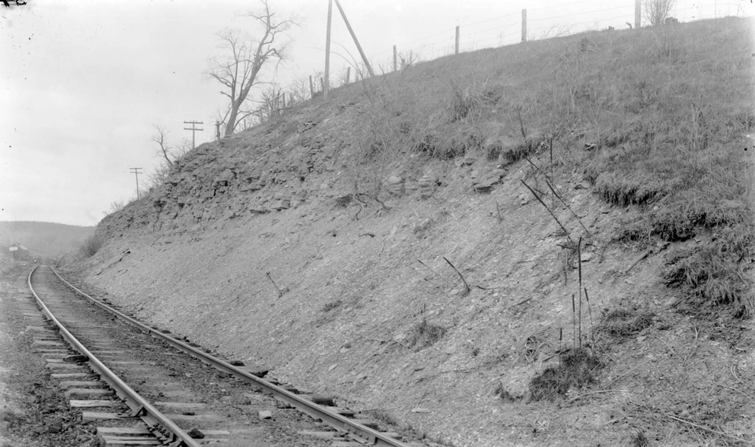](https://iowaculture.gov/sites/default/files/primary-sources/images/history-education-pss-geography-maquoketa-source.jpg)

Calvin, Samuel, "Railroad cut through Maquoketa Shales, Graf, Iowa, late 1890s or early 1900s," between 1895 and 1910. [Courtesy of University of Iowa Libraries](http://digital.lib.uiowa.edu/cdm/singleitem/collection/calvin/id/22/rec/110)

**Title:** Railroad Cut Through Maquoketa Shales, between 1895 and 1910

**Description:** This railroad cut through Maquoketa Shales - which is soft and fine sedimentary rock that forms from mud or clay and can be split easily into fragile slabs. The photo was taken by Samuel Calvin in Graf, Iowa, sometime between 1895 and 1910.

**Question:** What do you notice about the hillside and the railroad tracks in this photo?How might the land around railroad tracks impact the trains?

**Iowa Map Issued by the Board of Railroad Commissioners, 1915**

[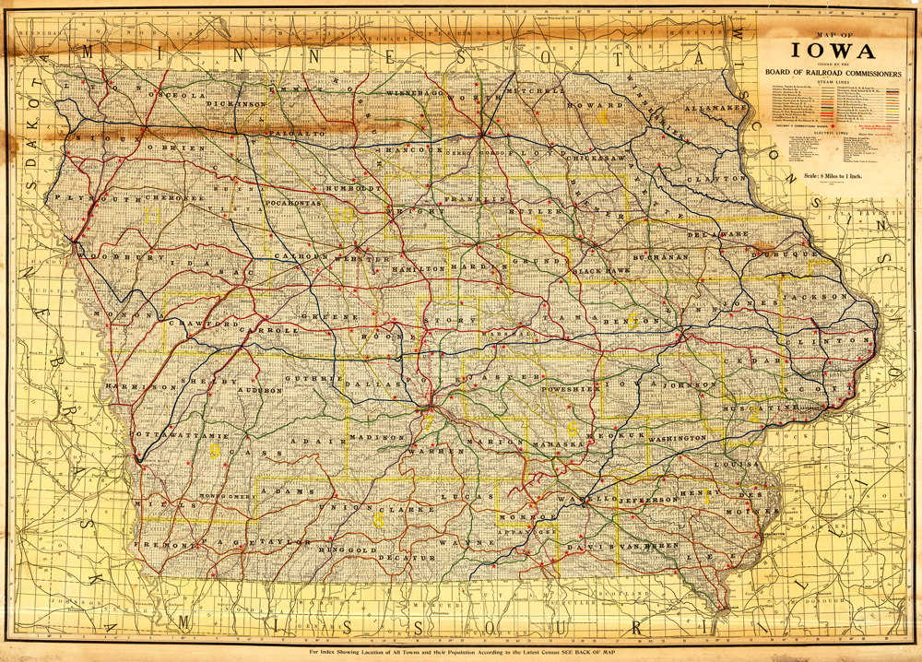](https://iowaculture.gov/sites/default/files/primary-sources/images/history-education-pss-geography-1915map-source.jpg)

"Map of Iowa, issued by the Board of Railroad Commissioners, 1915," Rand McNally and Company, Iowa Board of Railroad Commissioners, 1915. [Courtesy of University of Iowa Libraries](http://digital.lib.uiowa.edu/cdm/singleitem/collection/atlases/id/3797/rec/5)

**Title:** Iowa Map Issued by the Board of Railroad Commissioners, 1915

**Description:** The transportation map features more than 26 railroads in Iowa in 1915. The map, which was published by Rand McNally and Company, includes the railroad lines of companies such as the Wabash Railroad, the Union Pacific Railroad Company and the Atlantic Northern Railroad.

**Question:** What do you notice about where the railroads meet? What do you predict that the rail cars are carrying?

**Routes of Proposed Railroads in Iowa, 1851**

[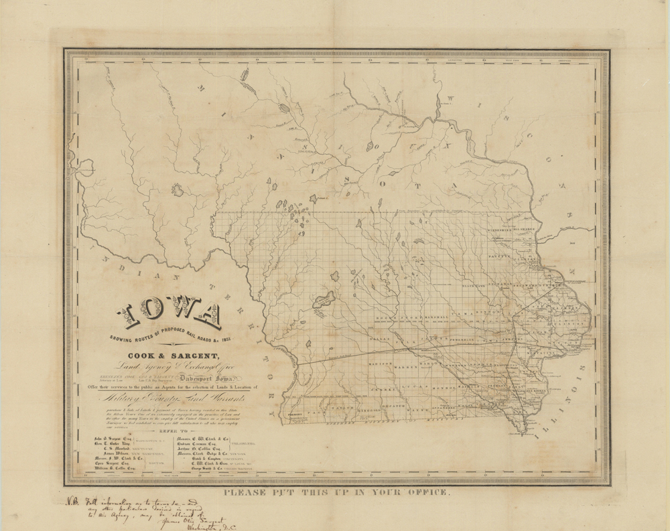](https://iowaculture.gov/sites/default/files/primary-sources/images/history-education-pss-geography-1851iowa-source_0.jpg)

"Iowa: showing routes of proposed rail roads & c, 1851," Cook & Sargent Land Agency & Exchange Office, 1851. [Courtesy of University of Iowa Libraries](http://digital.lib.uiowa.edu/cdm/singleitem/collection/sheetmaps/id/71/rec/2789)

**Title:** Routes of Proposed Railroads in Iowa, 1851

**Description:** The 1851 map highlights the proposed routes for railroads in Iowa that was published by the Cook & Sargent Agency & Exchange Office.

**Question:** What parts of the state of Iowa did the railroads have plans for in 1851? Why would they have plans for these areas? Based on this map, what were the railroads trying to connect?